National Disability Voter Registration Week

*July 15-19, 2019*

# Social Media Toolkit

The [REV UP Campaign](https://www.aapd.com/REVUP) is coordinating **National Disability Voter Registration Week** (NDVRW) during the week of **July 15-19, 2019** to make a concerted effort to get people with disabilities registered to vote, educated about this year’s election, and prepared to cast a ballot in November. With numerous events and activities happening around the country during this time, we also hope to garner attention from media and candidates running for office. Moving forward, we plan to hold NDVRW annually in the third week of July, just before the anniversary of the Americans with Disabilities Act (ADA).

The REV UP Campaign, launched by the [American Association of People with Disabilities](https://www.aapd.com) (AAPD) in 2016, is a nonpartisan initiative that coordinates with national, state, and local disability organizations to increase the political power of the disability community while also engaging candidates and the media on disability issues. The Campaign focuses on voter registration, education, access, and engagement. REV UP stands for *Register!* *Educate!* *Vote!* *Use* your *Power!*

Use this Social Media Toolkit to help us spread the word about NDVRW! For additional resources on organizing voter registration events and other ways to participate in NDVRW, please [**download the full NDVRW Toolkit**](https://www.aapd.com/2019-national-disability-voter-registration-week-toolkit/).

## Logos, Images, Graphics, and Signs

The REV UP Campaign has several logos, graphics, images, and signs freely available for partners to use or modify for outreach and in promotional materials.

[**Access the REV UP Dropbox to view and download materials**](https://www.dropbox.com/sh/4y3qs92r80ajv23/AABfeAabZ6xBgxrzX472Wj7Ba?dl=0)

### Some examples of available logos and graphics include:

A logo design that says: 

Be Seen
Be Heard
Be Counted
(beside each phrase a stick figure is being drawn until it reaches a full stick person image beside "be counted"

REV UP Campaign with a voting box decorated as the American flag. It has a power fist on the side in blue.

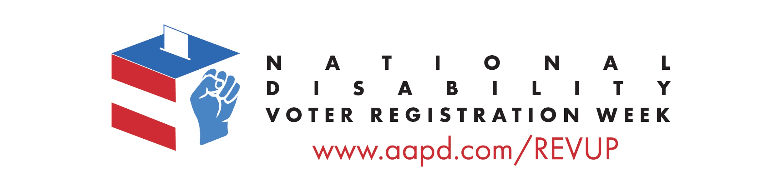

## An person in a wheelchair and a woman loooking outside. The bottom of the image says "Register" in blackk with the R in red.

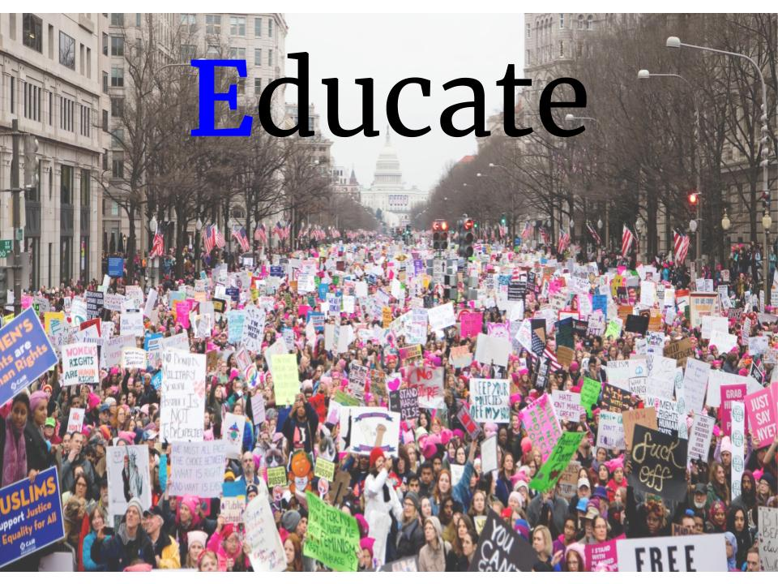

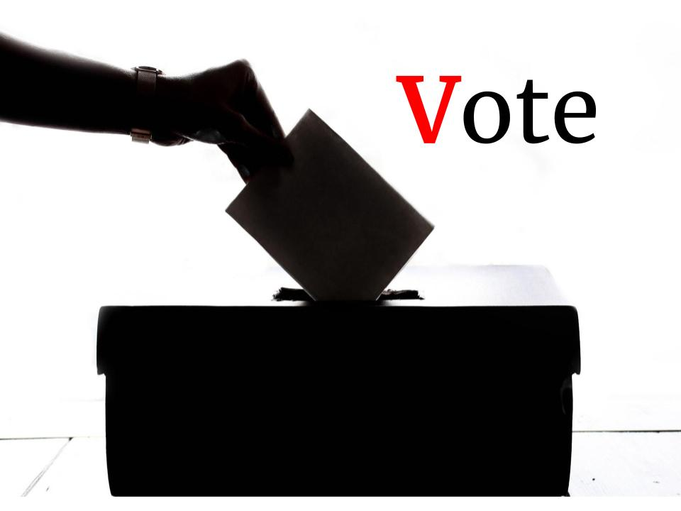

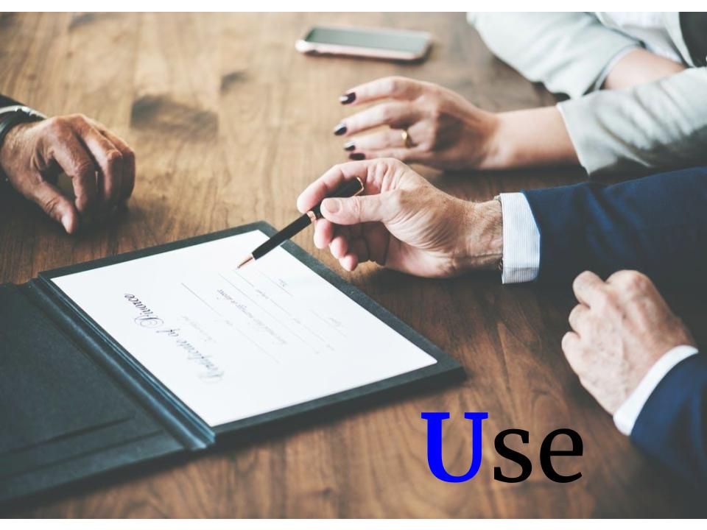

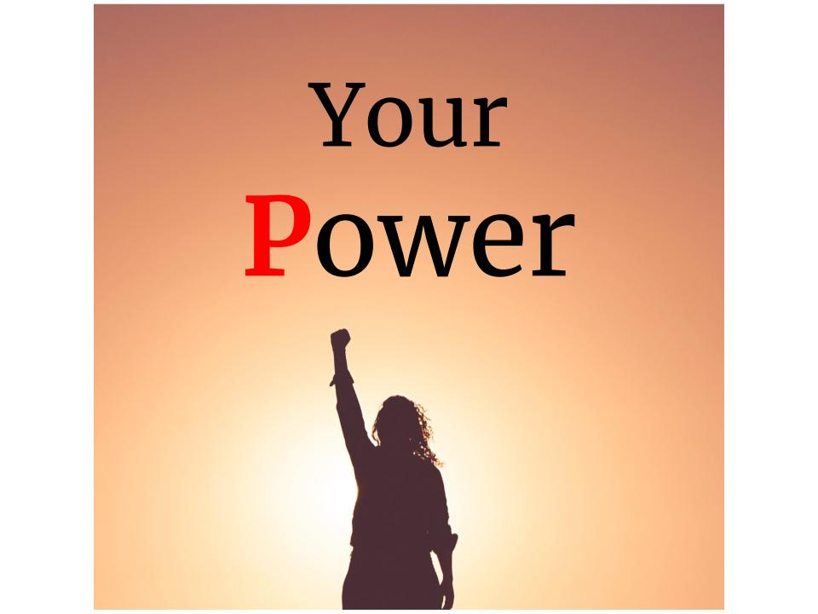

## Sample Social Media Posts

Be sure to use **#REVUP** and **#DisabilityVote** when you post! You can also tag [@AAPD](https://twitter.com/AAPD) on Twitter and [@DisabilityPowered](https://www.facebook.com/DisabilityPowered/) on Facebook.

**TWITTER**

**Sample Post 1:** Issues important to people with disabilities MUST be part of the platform for any candidate running for public office -- that’s why I’m joining #REVUP and registering to vote 7.15–7.19. Let’s make the #DisabilityVote count: [https://www.aapd.com/advocacy/voting/](https://nam03.safelinks.protection.outlook.com/?url=https%3A%2F%2Fwww.aapd.com%2Fadvocacy%2Fvoting%2F&data=02%7C01%7C%7Cd610b163a2864e03dd9e08d6ea17ab60%7Cb5c7d6f345e0425894917a8316bf8b3c%7C0%7C0%7C636953784739473729&sdata=haw83GywKYjtQV2SQIUgjIAM6CKEZTUdV3hFMteVPNE%3D&reserved=0)  
***[Insert selfie with PIN] OR [Insert Rev Up Social Image (see above)]***

**Sample Post 2:** If people with disabilities voted at the same rate as people w/o disabilities in 2016, there would have been an additional 2.2 million votes! Together, lets #REVUP & make sure the disability vote is heard. Get out & [register](https://www.vote.org/register-to-vote/) 7.15–7.19, it only takes 2 minutes! #DisabilityVote [https://www.aapd.com/advocacy/voting/](https://nam03.safelinks.protection.outlook.com/?url=https%3A%2F%2Fwww.aapd.com%2Fadvocacy%2Fvoting%2F&data=02%7C01%7C%7Cd610b163a2864e03dd9e08d6ea17ab60%7Cb5c7d6f345e0425894917a8316bf8b3c%7C0%7C0%7C636953784739483733&sdata=MlfZnAd3324oEYmgN8eQtlQgG7sS2Y4dSz7w9viTgK0%3D&reserved=0)   
***[Insert selfie with PIN] OR [Insert Rev Up Social Image (see above)]***

**Sample Post 3:** People with disabilities accounted for 1/6 of the total electorate in 2016, and issues important to our community MUST be included on all candidates’ platform. Join me as I #REVUP and [register to vote](https://www.vote.org/register-to-vote/) 7.15-7.19 #DisabilityVote <https://www.aapd.com/advocacy/voting/>   
***[Insert selfie with PIN] OR [Insert Rev Up Social Image (see above)]***

**Sample Post 4:** "VOTE as if your life depends on it—Because it DOES!" - Justin Dart #REVUP #DisabilityVote

[www.aapd.com/REVUP](http://www.aapd.com/REVUP)

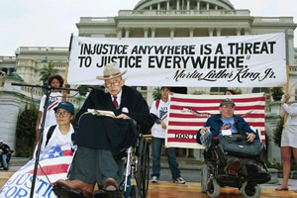

**Sample Post 5:** Are you ready to #REVUP‬ for National Disability Voter Registration Week 2019? Learn how you can get involved‬‬‬ this July. #DisabilityVote‬‬‬‬‬‬‬‬‬‬‬‬‬‬‬‬ [www.aapd.com/NDVRW](http://www.aapd.com/NDVRW)

***[Insert selfie with PIN] OR [Insert Rev Up Social Image (see above)]***

**Sample Post 6:** I vote to support #DisabilityRights! Learn more at <http://www.aapd.com/REVUP> #REVUP #DisabilityVote

***[Insert selfie with PIN] OR [Insert Rev Up Social Image (see above)]***

**Sample Post 7:** Want to #REVUP your state? Check out this list of state resources and events to see who is already organizing and where you can get involved. #DisabilityVote <https://www.aapd.com/advocacy/voting/state-resources-and-events/>

***[Insert selfie with PIN] OR [Insert Rev Up Social Image (see above)]***

**Sample Post 8:** I vote because it’s my right! Spread the word! It only takes 2 minutes to [register](https://www.vote.org/register-to-vote/)! <http://www.aapd.com/REVUP> #REVUP #DisabilityVote

***[Insert selfie with PIN] OR [Insert Rev Up Social Image (see above)]***

**Sample Post 9:** National Disability Voter Registration Week 2019 is July 15-19! Get [registered](https://www.vote.org/register-to-vote/) and be heard! [www.aapd.com/NDVRW](http://www.aapd.com/NDVRW) #REVUP #DisabilityVote

***[Insert selfie with PIN] OR [Insert Rev Up Social Image (see above)]***

**Sample Post 10:** Verify your voter registration status and find your polling place with this tool from @HeadCountOrg: <https://www.headcount.org/verify-voter-registration/> #REVUP #DisabilityVote

***[Insert selfie with PIN] OR [Insert Rev Up Social Image (see above)]***

**Sample Post 11:** Young people and people with disabilities are underrepresented at the polls – that means that young people *with* disabilities have got to get out the vote! It only takes 2 minutes to [register](https://www.vote.org/register-to-vote/)! @rootedinrights #REVUP #DisabilityVote <http://www.rootedinrights.org/videos/voting/youth-vote/>

***[Insert selfie with PIN] OR [Insert Rev Up Social Image (see above)]***

**Sample Post 12:** Voting rules are different in every state and the disability vote needs to be part of EVERY election - local, state, and national. Look up how to register and when to vote in [the state your organization is in] with [USA.gov.](https://www.usa.gov/register-to-vote#item-212998)

**FACEBOOK & INSTAGRAM**

**Sample Post 1:** Issues important to people with disabilities MUST be part of the platform for any candidate running for public office -- that’s why I’m joining #REVUP and [registering to vote](https://www.vote.org/register-to-vote/) this National Disability Voter Registration Week, July 15- 19. Let’s make the disability vote count. Learn more about registering here: [https://www.aapd.com/advocacy/voting/](https://nam03.safelinks.protection.outlook.com/?url=https%3A%2F%2Fwww.aapd.com%2Fadvocacy%2Fvoting%2F&data=02%7C01%7C%7Cd610b163a2864e03dd9e08d6ea17ab60%7Cb5c7d6f345e0425894917a8316bf8b3c%7C0%7C0%7C636953784739493742&sdata=S2m0oTCTdo%2FY8hlM81k%2B4Y5P6e9KDshGRw3VF9g6O9E%3D&reserved=0) #DisabilityVote

<image012.png>  
***[Insert selfie with PIN] OR [Insert Rev Up Social Image (see above)]***

**Sample Post 2:** Did you know that if people with disabilities voted at the same rate as people without disabilities in 2012, there would have been an additional 3 million votes cast? Together, lets #REVUP and make sure the disability vote is heard. Join me and get out and [register](https://www.vote.org/register-to-vote/) this National Disability Voter Registration Week, July 15 – 19. It only takes 2 minutes to register online! #DisabilityVote. Learn more:[https://www.aapd.com/advocacy/voting/](https://nam03.safelinks.protection.outlook.com/?url=https%3A%2F%2Fwww.aapd.com%2Fadvocacy%2Fvoting%2F&data=02%7C01%7C%7Cd610b163a2864e03dd9e08d6ea17ab60%7Cb5c7d6f345e0425894917a8316bf8b3c%7C0%7C0%7C636953784739493742&sdata=S2m0oTCTdo%2FY8hlM81k%2B4Y5P6e9KDshGRw3VF9g6O9E%3D&reserved=0)   
***[Insert selfie with PIN] OR [Insert Rev Up Social Image (see above)]***

**Sample Post 3:** People with disabilities accounted for 1/6 of the total electorate in 2016, and issues important to our community MUST be included on all candidates’ platform. Join me as I #REVUP and [register to vote](https://www.vote.org/register-to-vote/) this National Disability Voter Registration Week, July 15 – 19. #DisabilityVote. Learn more here:[https://www.aapd.com/advocacy/voting/](https://nam03.safelinks.protection.outlook.com/?url=https%3A%2F%2Fwww.aapd.com%2Fadvocacy%2Fvoting%2F&data=02%7C01%7C%7Cd610b163a2864e03dd9e08d6ea17ab60%7Cb5c7d6f345e0425894917a8316bf8b3c%7C0%7C0%7C636953784739503750&sdata=iWHOjK7jIhysp8PjK%2FQFXqqHwNJOY%2Bhvhilvf5zuZxM%3D&reserved=0)

***[Insert selfie with PIN] OR [Insert Rev Up Social Image (see above)]***

**Sample Post 4:** Not registered to vote? The #REVUP Campaign has you covered! Check out their online voter registration tool powered by @RockTheVote: [www.aapd.com/NDVRW](http://www.aapd.com/NDVRW) #DisabilityVote

***[Insert selfie with PIN] OR [Insert Rev Up Social Image (see below)]***

**Sample Post 5:** Ask your state and local elected officials to declare the week of July 15-19, 2019 as National Disability Voter Registration Week! Find a sample proclamation at [www.aapd.com/NDVRW](http://www.aapd.com/NDVRW). #REVUP #DisabilityVote

***[Insert selfie with PIN] OR [Insert Rev Up Social Image (see above)]***

**Sample Post 6:** [insert your organization’s name] is proud to be a part of the REV UP Campaign to increase the political power of the disability community! #REVUP #DisabilityVote Learn more at [www.aapd.com/REVUP](http://www.aapd.com/REVUP)

***[Insert selfie with PIN] OR [Insert Rev Up Social Image (see above)]***

**Sample Post 7:** In 2016, over 35 million people with disabilities were eligible to vote, but only 16 million did. Help us make sure our community is registered, educated, and engaged to exercise their civil right to vote! It only takes 2 minutes to [register online](https://www.vote.org/register-to-vote/)! #REVUP #DisabilityVote [www.aapd.com/REVUP](http://www.aapd.com/REVUP)

***[Insert selfie with PIN] OR [Insert Rev Up Social Image (see above)]***

**Sample Post 8:** [insert your organization’s name] is participating in National Disability Voter Registration Week this year! Visit [link to organizational website with event information] to learn more about our upcoming voter registration events! #REVUP #DisabilityVote

***[Insert selfie with PIN] OR [Insert Rev Up Social Image (see above)]***

**Sample Post 9:** VOTE. It's your right. A Guide to the Voting Rights of People with Mental Disabilities from @BazelonCenter, @autselfadvocacy, @NDRNadvocates, & @SRZLawFirm. #REVUP #DisabilityVote <http://www.bazelon.org/wp-content/uploads/2017/01/voting-rights-guide-2016.pdf>

***[Insert selfie with PIN] OR [Insert Rev Up Social Image (see above)]***

**Sample Post 10:** @VoteRiders has wallet-sized Voter ID Info Cards (in English & Spanish) for all 50 states & DC. They also provide voter ID assistance to citizens in every state and host a Voter ID Hotline: 1-844-338-8743. #REVUP #DisabilityVote <http://www.voteriders.org/voter-id-info-cards/>

***[Insert selfie with PIN] OR [Insert Rev Up Social Image (see above)]***

**Sample Post 11:** Young people and people with disabilities are underrepresented at the polls – that means that young people *with* disabilities have got to get out the vote! It only takes 2 minutes to [register online](https://www.vote.org/register-to-vote/)! @rootedinrights #REVUP #DisabilityVote <http://www.rootedinrights.org/videos/voting/youth-vote/>

***[Insert selfie with PIN] OR [Insert Rev Up Social Image (see above)]***

**Sample Post 12:** Voting policies vary by state - know the rules before going to the ballot box. Use this tool from @RockTheVote to learn about the voting policies in your state. #REVUP #DisabilityVote <https://www.rockthevote.org/voting-information/>

***[Insert selfie with PIN] OR [Insert Rev Up Social Image (see above)]***

**Sample Post 13:** Voting rules are different in every state and the disability vote needs to be part of EVERY election - local, state, and national. Look up how to register and when to vote in [the state your organization is in] with [USA.gov.](https://www.usa.gov/register-to-vote#item-212998)

**Posts for the week before NDVRW**

Initiate a countdown for NDVRW - you can either use a post from above or a new one, but something should be uploaded every day with the number of days until NDVRW left   
  
**Sample posts for Twitter/Facebook/Instagram:**

One week until #NDVRW! Get [registered](https://www.vote.org/register-to-vote/) and be heard! [www.aapd.com/NDVRW](http://www.aapd.com/NDVRW) #REVUP #DisabilityVote

***[Insert selfie with PIN] OR [Insert Rev Up Social Image (see above)]***

3 days until #NDVRW! Vote because it’s your right! Spread the word! It only takes 2 minutes to [register](https://www.vote.org/register-to-vote/)! <http://www.aapd.com/REVUP> #REVUP #DisabilityVote

***[Insert selfie with PIN] OR [Insert Rev Up Social Image (see above)]***

#NDVRW starts TOMORROW! Let’s make the disability vote count! Learn more about registering here: [https://www.aapd.com/advocacy/voting/](https://nam03.safelinks.protection.outlook.com/?url=https%3A%2F%2Fwww.aapd.com%2Fadvocacy%2Fvoting%2F&data=02%7C01%7C%7Cd610b163a2864e03dd9e08d6ea17ab60%7Cb5c7d6f345e0425894917a8316bf8b3c%7C0%7C0%7C636953784739493742&sdata=S2m0oTCTdo%2FY8hlM81k%2B4Y5P6e9KDshGRw3VF9g6O9E%3D&reserved=0) #DisabilityVote #REVUP

**Posts to use the week of NDVRW** (can also re-use above posts)**:**

@SpreadTheVoteUS provides direct assistance to help voters obtain the proper identification to vote in their state. They are currently active in Florida, Georgia, Tennessee, Texas, and Virginia. #REVUP #DisabilityVote

<https://www.spreadthevote.org/>

@NpVOTE provides tools and resources to expand the role of America's nonprofits in promoting active civic participation and democracy. #REVUP #DisabilityVote

<http://www.nonprofitvote.org/>

The #REVUP Campaign aims to increase the political power of people with disabilities through voter registration, education, and engagement. Learn more at [www.aapd.com/REVUP](http://www.aapd.com/REVUP). #DisabilityVote

**Suggestions:**

* Introduce REV UP by having each word on its own picture - **REV UP** stands for **R**egister! **E**ducate! **V**ote! **U**se your **P**ower!

## Social Media Photo Campaign

This year, we are encouraging advocates and voters to post a selfie or photo of themselves holding a sign to express their commitment to voting in the upcoming election.

### Instructions

1. Print out a sign (templates are linked below)
2. Write something on your sign (if applicable)
3. Take a selfie of yourself and the sign or ask a friend to take a photo of you holding it
4. Post the photo to Facebook or Twitter
5. Be sure to tag your post with **#REVUP** and **#DisabilityVote**
6. Please also tag AAPD – we are on Facebook at [@DisabilityPowered](https://www.facebook.com/DisabilityPowered/) and Twitter at [@AAPD](https://twitter.com/AAPD)

## Press Release Template

The press release template linked below is open for REV UP partners to use and modify as they see fit to promote their involvement with National Disability Voter Registration Week this year.

* [**Press Release Template – REV UP National Disability Voter Registration Week 2019**](https://www.aapd.com/press-release-template/)

### Some considerations for your press release:

* Please use “National Disability Voter Registration Week” and mention the REV UP Campaign in your release. This helps us build brand awareness around NDVRW and identifies the REV UP Campaign as a national effort to increase the political power and participation of people with disabilities.
* Clearly indicate the details about your voter registration events (date, time, location, and organizer contact information).
* Send the release to state and local media in advance of your event.

## Request a Proclamation

A great way to raise awareness about NDVRW is to advocate for your state, city, town, etc. to recognize it. You can reach out to your Governor, Mayor, City Council, County Commissioner, State Representative, etc. to request that they issue a proclamation declaring the week in question National Disability Voter Registration Week ([a draft Proclamation is available here](https://www.aapd.com/wp-content/uploads/2017/04/National-Disability-Voter-Registration-Week-Resolution.docx)). This is a great way to develop or leverage a relationship with your local and state government. Please send any Proclamations you get to [programs@aapd.com](mailto:programs@aapd.com) so we can show the influence and support of REV UP across the country!

## Submit Information About Your NDVRW Event

If your organization, city, or state is putting together an event for National Disability Voter Registration Week or REV UP, then please submit information about the event onto our website <https://aapd.kindful.com/register/rev-up-events>. Any information will be added to the State Resources and Events page on AAPD's website.

Visit the [National Disability Voter Registration Week (NDVRW) webpage](https://www.aapd.com/advocacy/voting/national-disability-voter-registration-week/) for additional resources on holding voter registration events and other ideas on how to participate in NDVRW.

## Questions?

Do you have questions about National Disability Voter Registration Week or need additional resources? Let us know! Email Keri Gray ([kgray@aapd.com](mailto:kgray@aapd.com)).

**Thank You!**